Something else Villiers were in to was petrol stoves. So far we do not know when they started making them, or why, or when they stopped making them. But here are some, all of them found in the John Shaw and Sons catalogue for 1939:

This is the "Mar-Vil". It had a single burner and could boil a quart of water in less than 4 minutes.  The finish is black enamel and chromium plate. The back and side shields, and the legs, all folded down. | 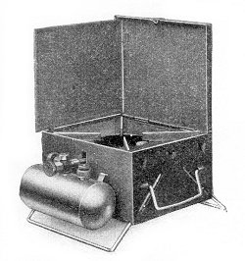

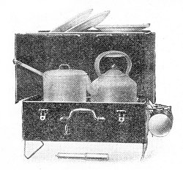 | This is the "Inferno", which had two burners and a plate rack. (These days an advertiser would have to add "plates not included"). Its materials and finish are the same as the Mar-Vil but Shaws add that this is made out of strong sheet steel - presumably the Mar-Vil was as well. The Inferno "shuts down like an attaché case in one minute".

This is the "Farmer's Glory". It cost the same as the Inferno and performed the same. But it does not seem to fold up. The only difference noticeable in Shaw's text is that in this case they mention that the burners "can be regulated from powerful flame to gentle simmer". | 

