WORKING DAY

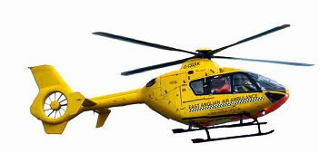
SUNDAY 20TH MARCH
10AM
STANFIELD on the B1145
Contact Adrian Hall
01328 851571
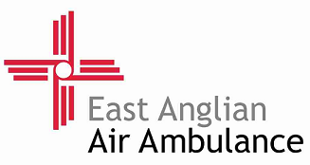
ALL PROCEEDS TO THE EAST ANGLIN AIR AMBULANCE

