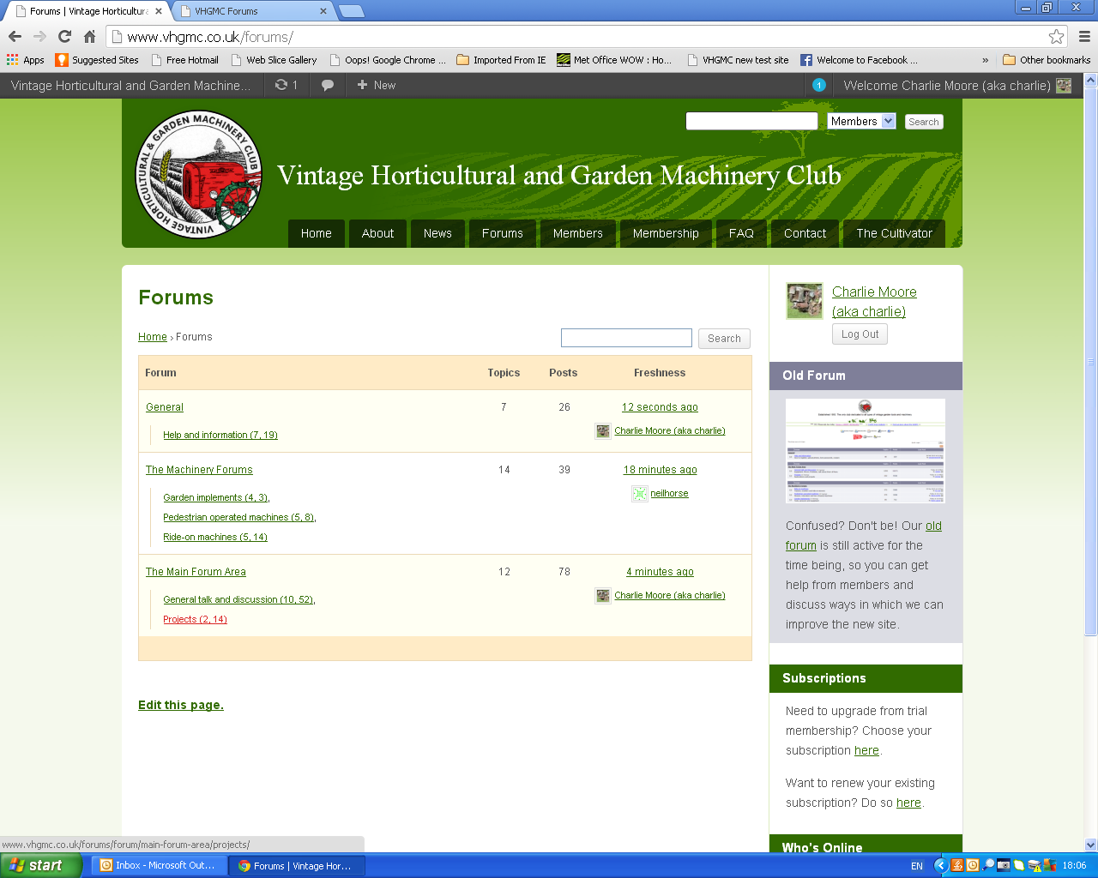
Click on projects

Then scroll down till the screen looks like the below
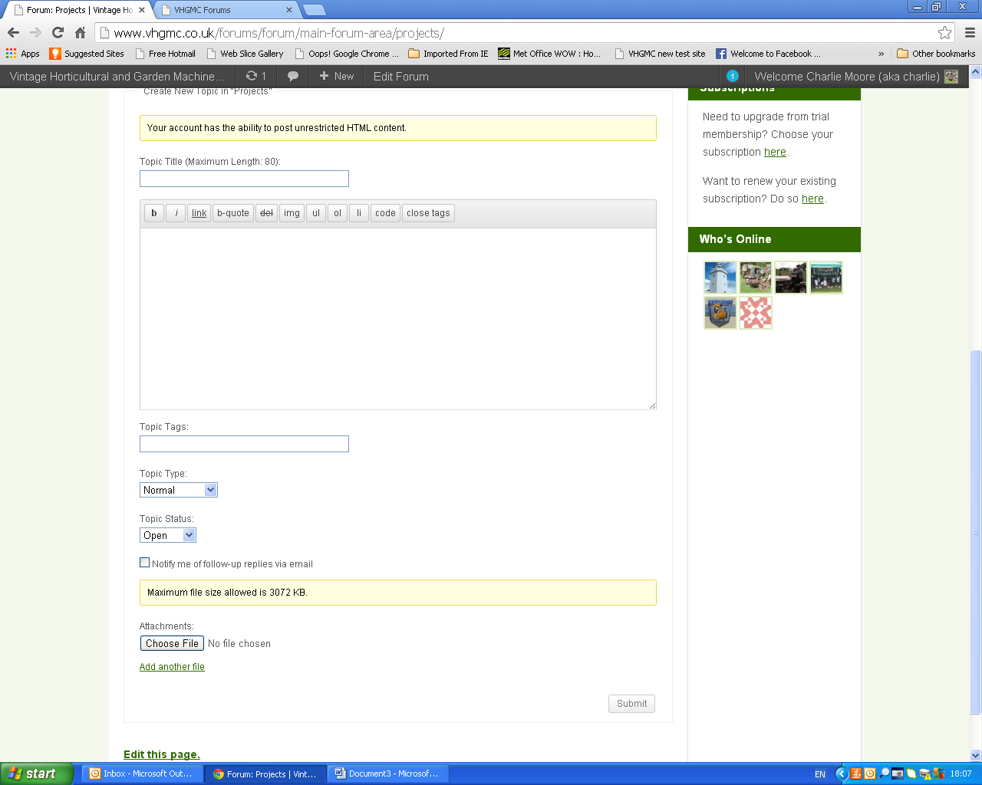
Enter topic name

Enter text here
Add photos etc
Finally click on submit
New topic should now appear in the Projects section.

